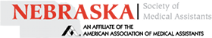
Registration Form
NSMA Conference 2024
APRIL 26th-27th- Graduate Hotel in Downtown Lincoln, NE
NAME |  | CREDENTIALS
ADDRESS

CITY | STATE AND ZIP
PHONE | YOUR EMAIL
AAMA MEMBER ID

1. ____YES ____NO Is this your first NSMA Conference?
2. ____YES ____NO Are you a past President of NSMA?
3. ____YES ____NO Newly certified CMA (AAMA) since 2023 Conference?
4. ____YES ____NO Recertified your CMA (AAMA) credential since 2023 Conference?
FULL TWO-DAY REGISTRATION (snacks, beverages, and lunch both Friday and Saturday, 11 CEUs)
_____Members (meals and educational sessions) $150
Registration deadline: April 12, 2024
No refunds after: April 19, 2024
OPTIONS FOR PAYMENT:
** By check to NSMA Conference Fund**
**By Venmo**(add $5 processing fee)
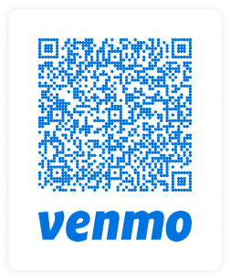
Mailing address for registration and check payment:
Jen Kocian, CMA (AAMA)
1601 Torreys Drive
Lincoln, NE 68521

Email address for registration only:
NSMAtreasurer1@gmail.com
_____Non-Members (meals and educational sessions) $240
_____Students (meals and educational sessions) $120
FRIDAY ONLY APRIL 26th (snacks, beverages, lunch & CEU’s)
_____Members (meal and educational sessions) $110
_____Non-Members (meal and educational sessions) $150
_____Students (meal and educational sessions) $90
SATURDAY ONLY April 27th (snacks, beverages, lunch, & CEU’s)
_____Members (meals and educational sessions) $110
_____Non-Members (meals and educational sessions) $150
_____Students (meals and educational sessions) $90
ADDITIONAL OPTIONS
____ GUEST Saturday luncheon for awards & officer installation $30
____ $15 - LATE FEE REGISTRATION (If postmarked after April 12th or payment on Conference day)

**To help the staff of our venue with meal count, please mark which meals you will be attending**
____ I plan on attending the Friday lunch
____ I plan on attending the Saturday awards and installation luncheon

JEANS FRIDAY: This is an annual NSMA Fundraiser. On Friday only, attendees can wear jeans for a $5.00 donation.
*This is payable at the registration desk - CASH OR VENMO ONLY! Otherwise, business casual is appropriate dress for the conference.

For the courtesy towards other attendees and per the policies defined by our organization, no alcoholic beverages or smoking allowed during NSMA sponsored events. Failure to follow this policy may result in exclusion or removal from conference events.

**Conference name badge must be worn for admittance to all educational sessions and meals**

